Laporan Praktikum 4

Nama : Fakhrul Anam

Kelas : 5A

NIM : 18090113

1. Source code

Web.php 🡪 application/controllers/

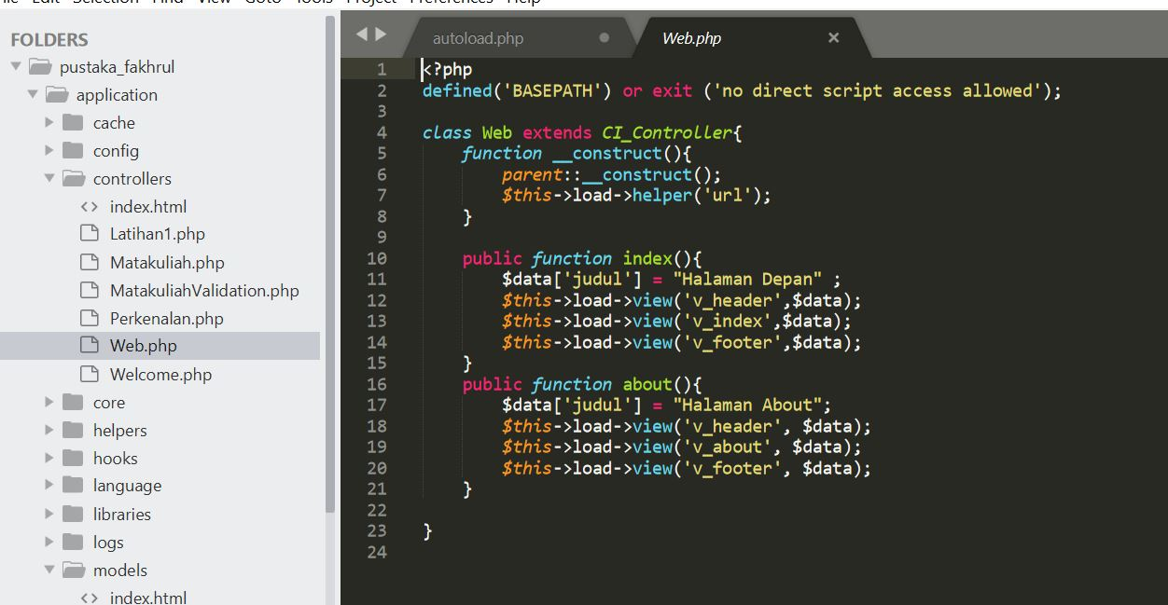

v_header.php🡪application/views/

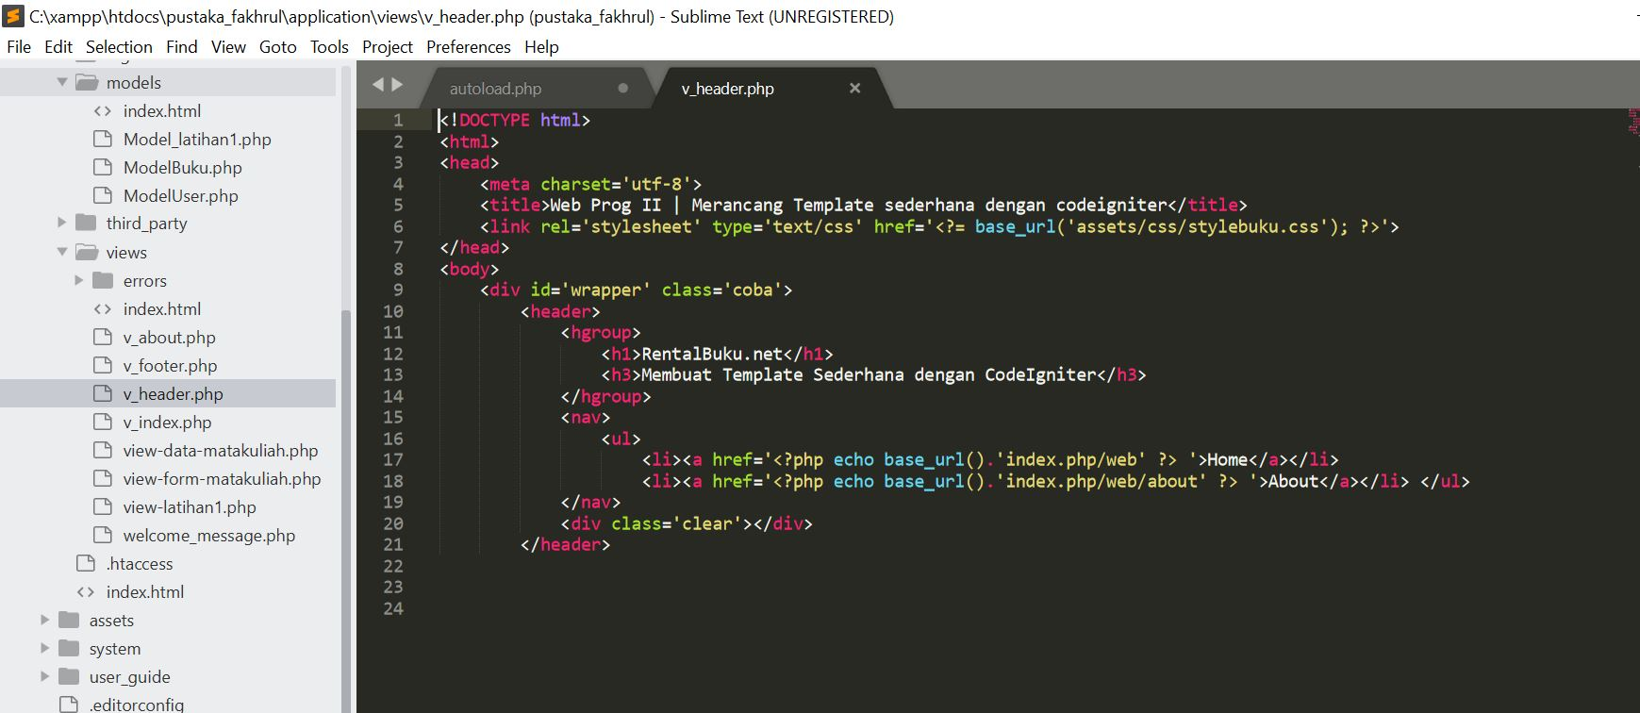

v_index.php 🡪 application/views/

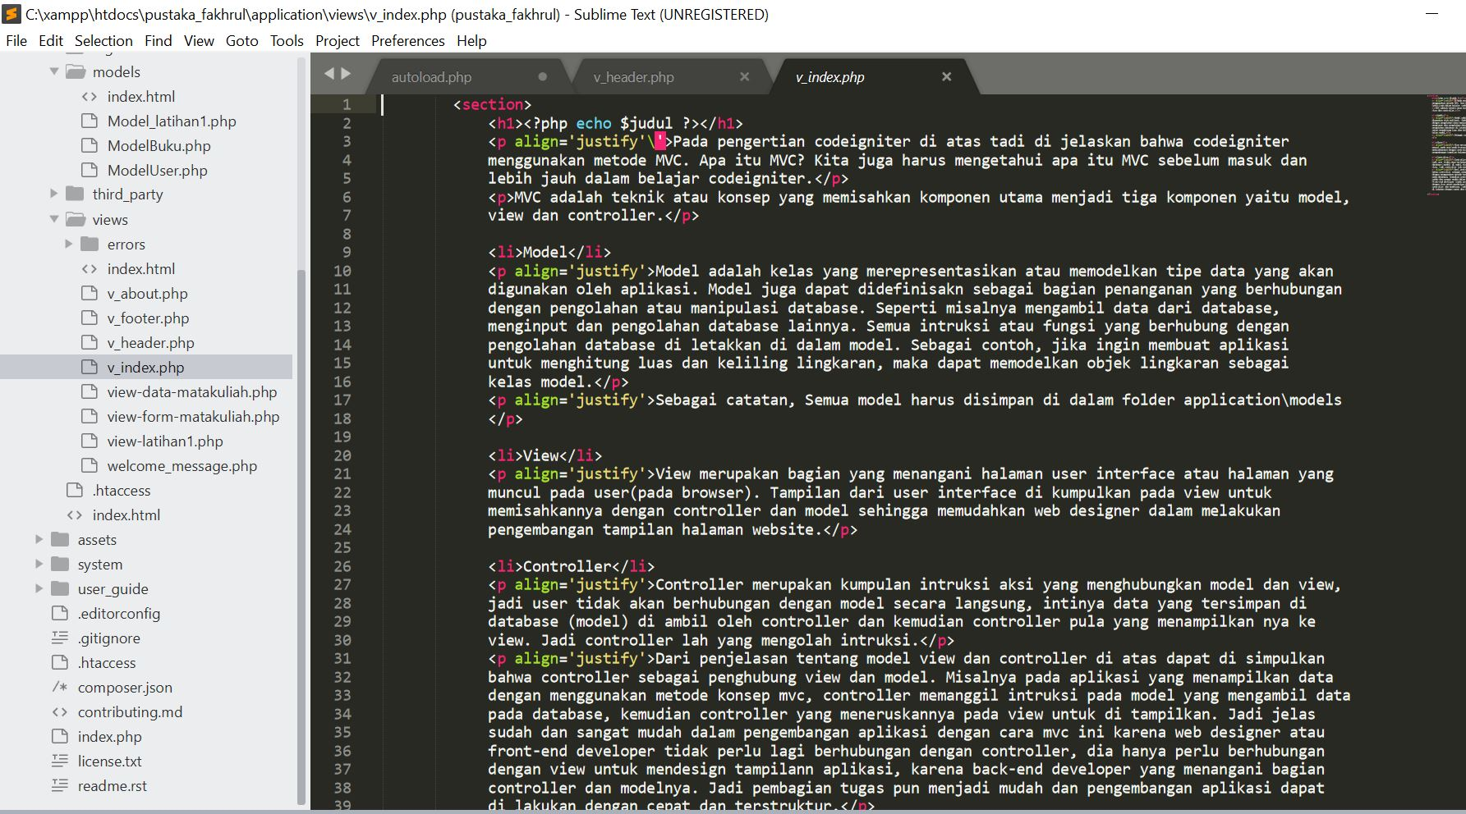

v_footer🡪 application/views/

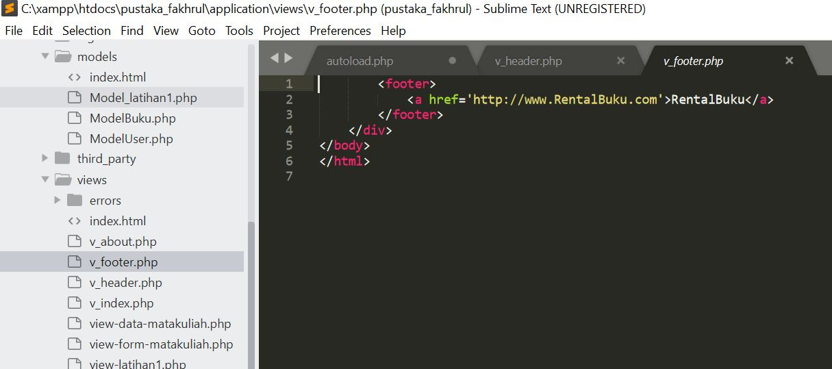

stylebuku.css 🡪 pustaka-booking/assets/css/

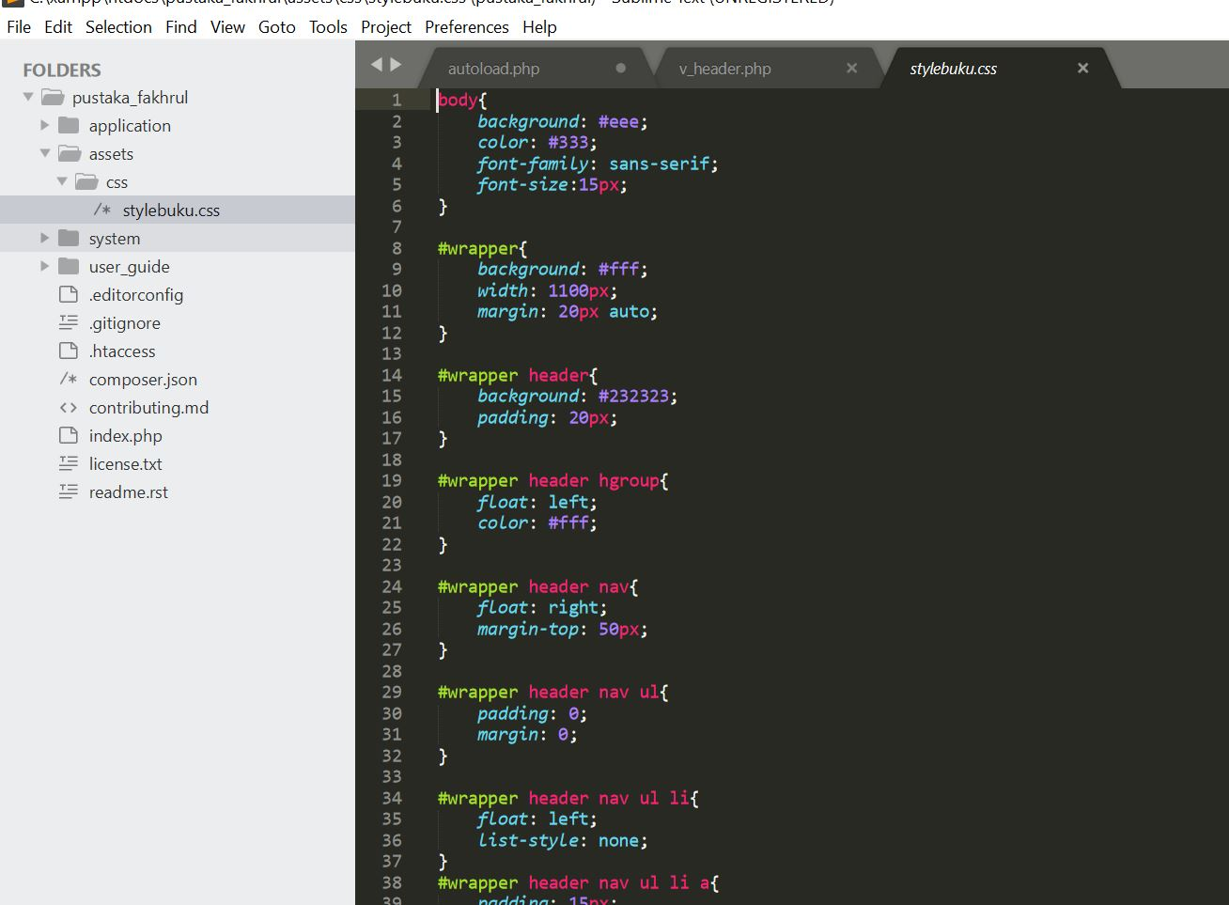

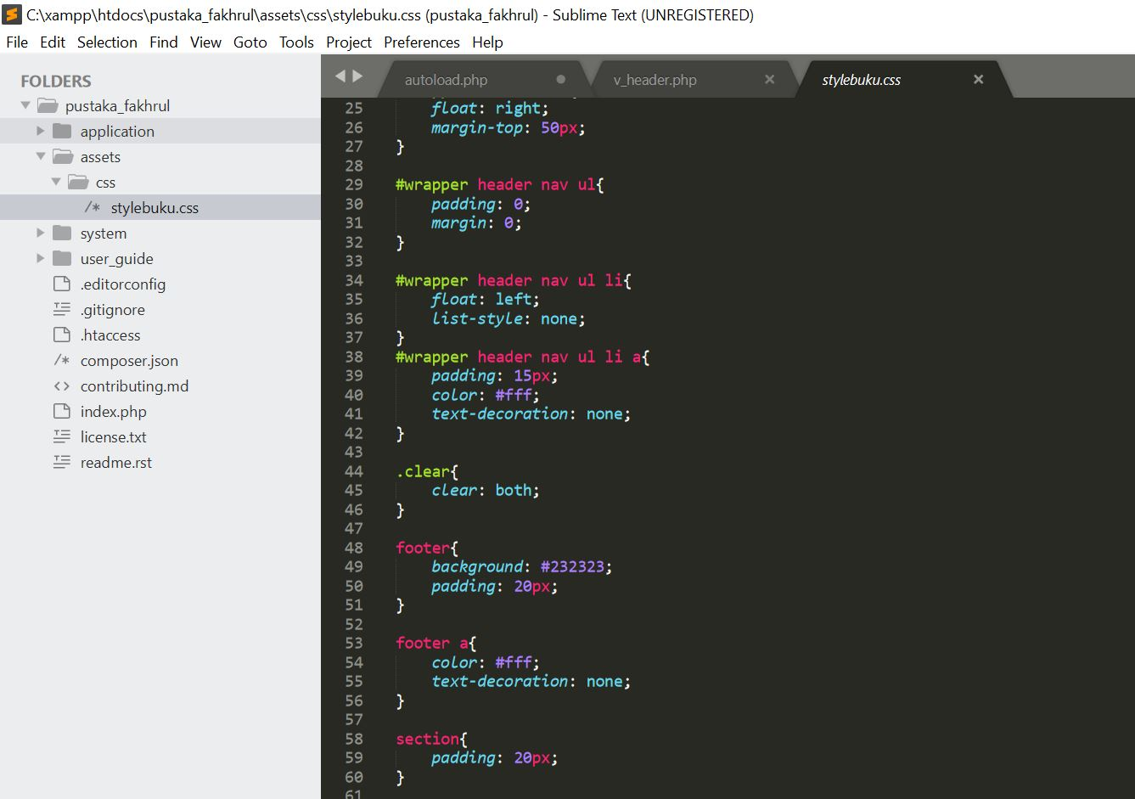

config.php 🡪 application/config/

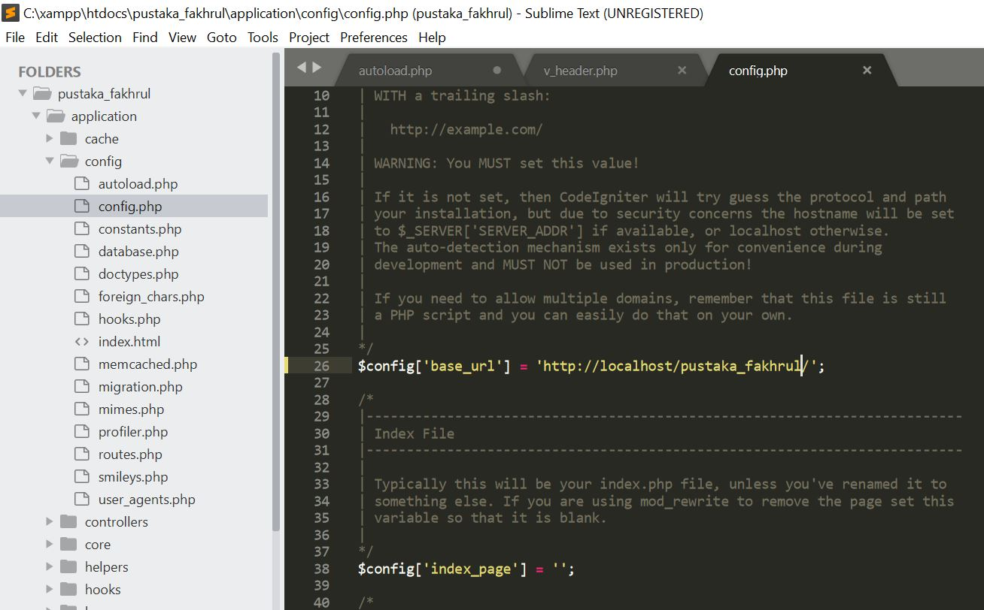

autoload.php 🡪 application/config/

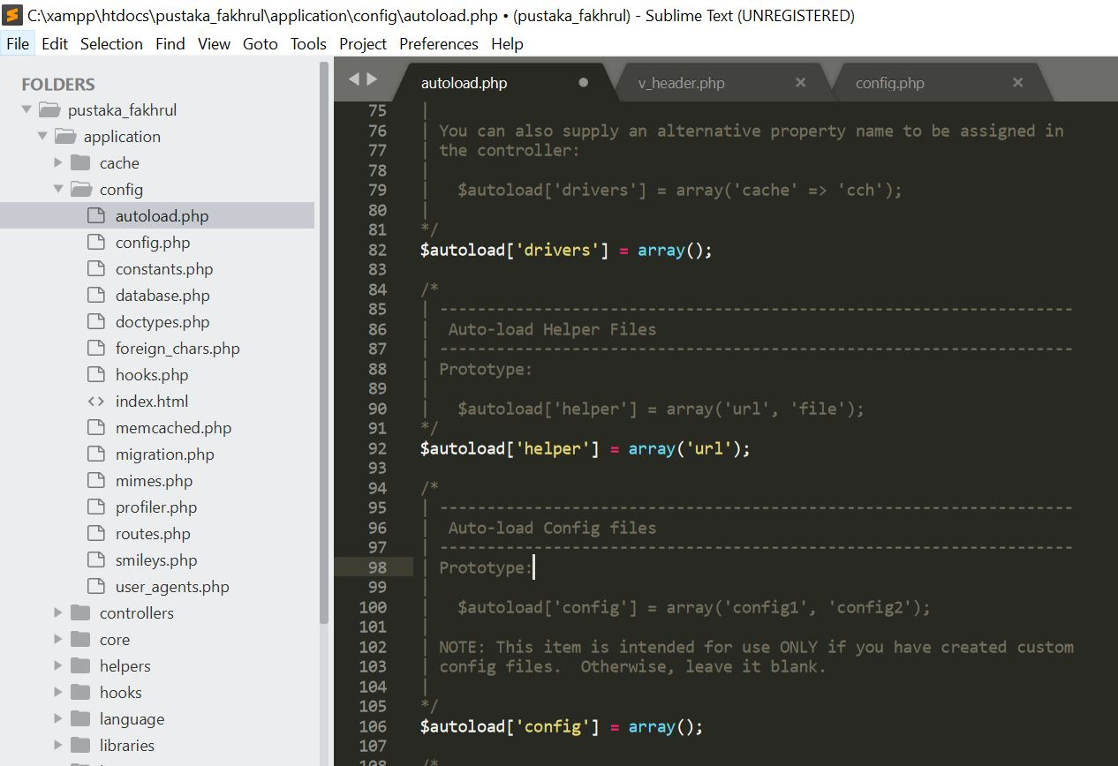

v_about.php 🡪 application/views/

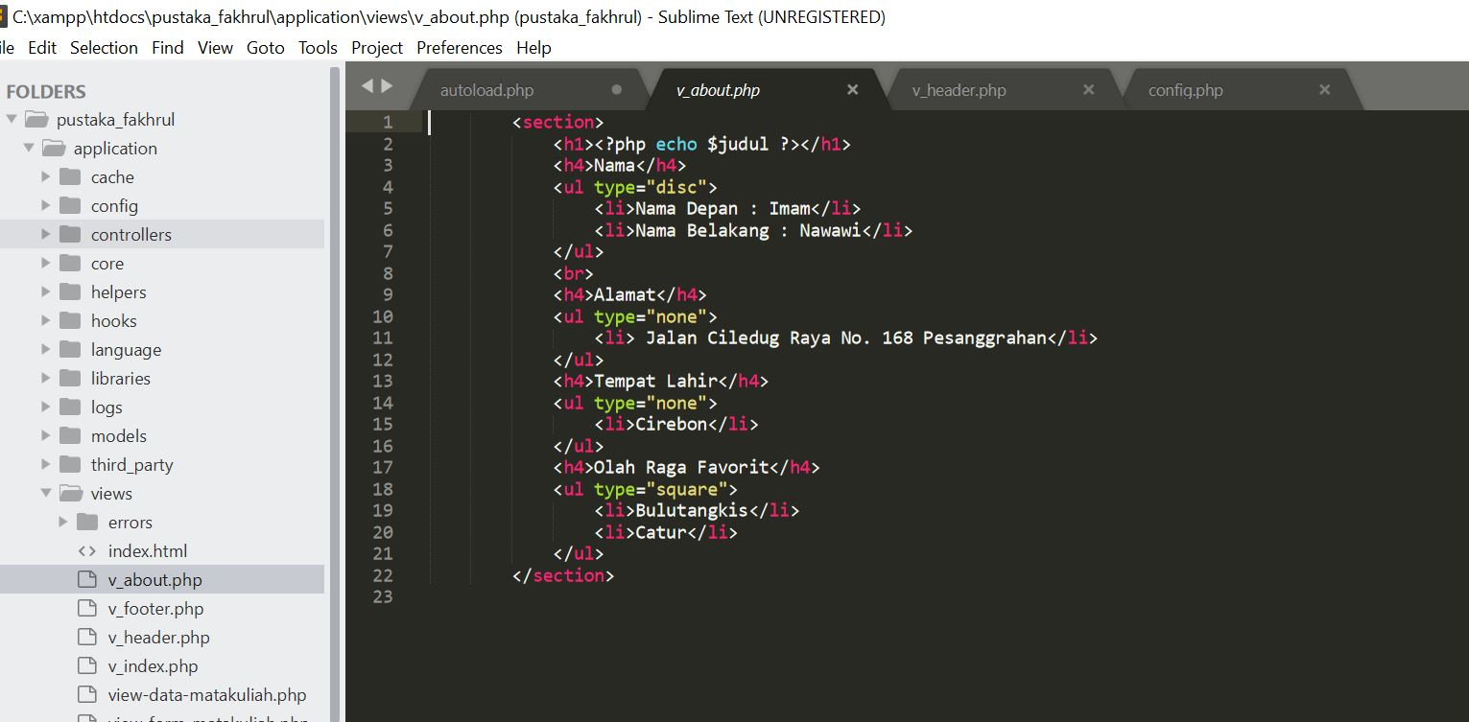

1. Capture Output Program

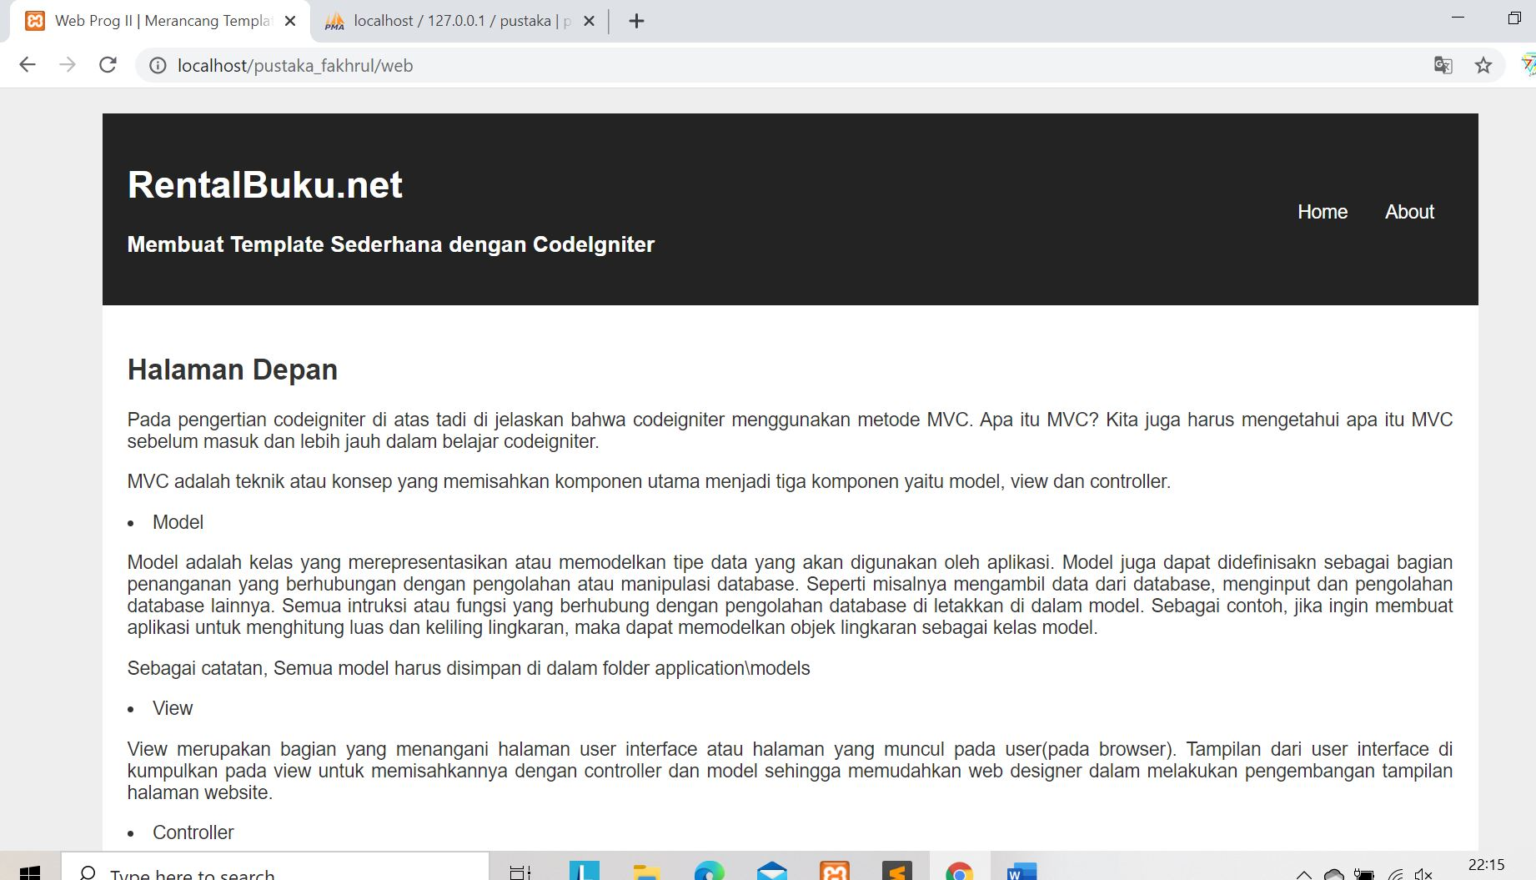

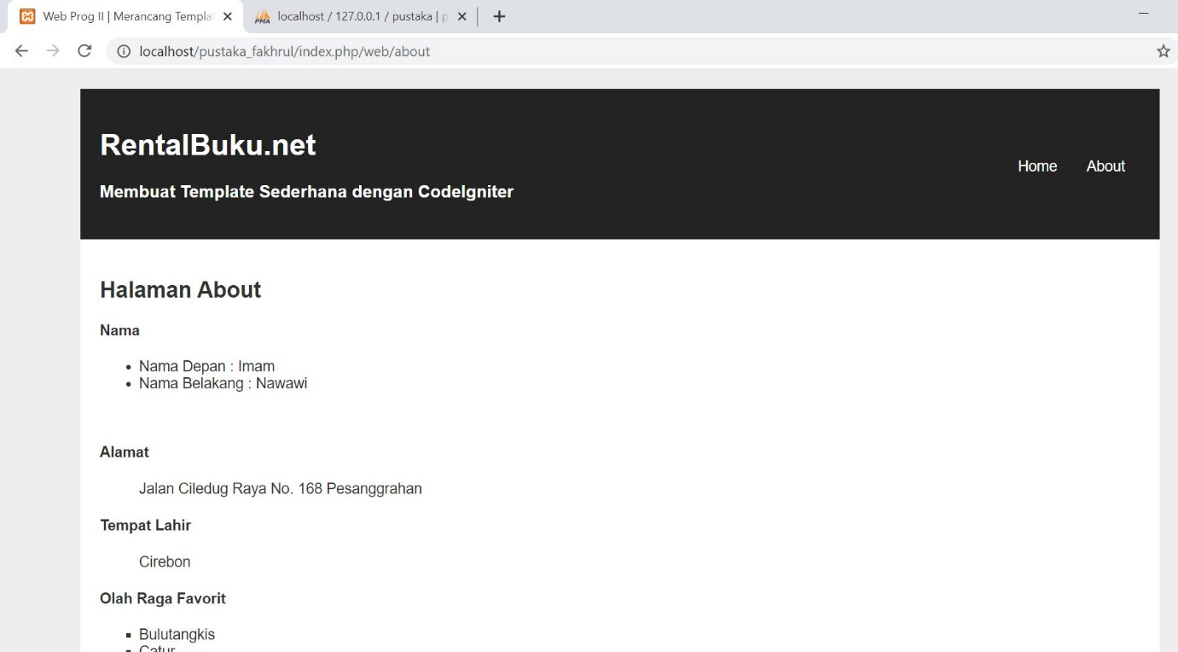

1. URL

<http://localhost/pustaka_fakhrul/index.php/web>

<http://localhost/pustaka_fakhrul/index.php/web/about>